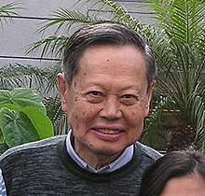Name: 李楊振寧Yang Chen Ning
Dates: Oct 1, 1922 ~
Nationality: American Chinese
Field: Chemistry
Nobel: 1957(Physics): Parity Laws
Contributions:

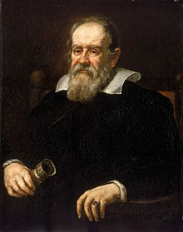Name: Galileo Galilei
Dates: Feb 15, 1564 ~ Jan 8, 1642
Birthplace: Pisa, Italy
Field: astronomy, mathematics, physics
Nobel: NO
Contributions: Foundations for modern experimental science; solar system (earth revolves around sun)

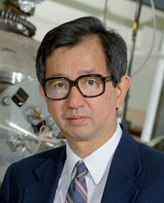Name: 李遠哲 Lee Yuan Tseh
Dates: Nov 19, 1936 ~
Nationality: Chinese (ROC)
Field: Chemistry
Nobel: 1986(Chemistry): Dynamics of Chemical Processes
Contributions:

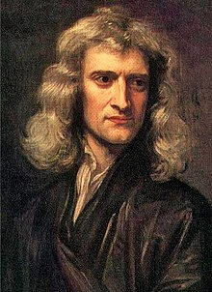Name: Isaac Newton
Dates: Jan 4, 1642 ~ Mar 31, 1727
Birthplace/Nationality: England
Field: mathematics & physics
Nobel: NO
Contributions: Newton’s 3 Laws of Motion including F=ma; optics, universal gravitation (G)
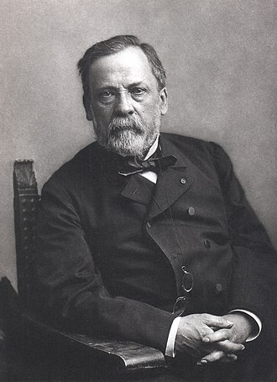Name: Louis Pasteur
Dates: Dec 27, 1822 - Sept 28, 1895
Nationality: French
Field: Chemistry/Biology
Nobel: NO
Contributions: Father of Microbiology (Germ Theory). Vaccinations (anthrax, rabies), Pasteurization (milk, wine)

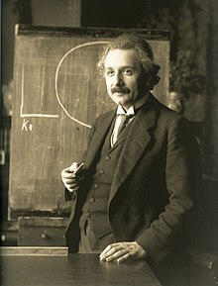Name: Albert Einstein
Dates: Mar 14, 1879 ~ April 18, 1955
Nationality: Germany (Jewish), became American
Field: Theoretical Physics
Nobel: 1921(Physics): Photo-electricity
Contributions: Formation of theory of specific and general relativity, E=mc2

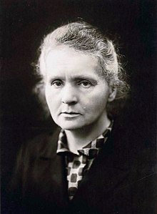Name: Marie Curie
Dates: Nov 7, 1867 ~ July 4, 1934
Birthplace: Warsaw, Poland
Field: chemistry and physics
Nobel 1: 1903(Physics): radioactivity
Nobel 2: 1911(Chemistry): discovery of radium and polonium
Contributions: development of X-Rays as a medical device; radiation challenged conservation of energy
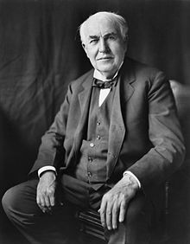Name: Thomas Edison
Dates: Feb 11, 1847 ~ Oct 18, 1931
Birthplace: Ohio, USA
Field: Inventor
Nobel: NO
Contributions: electrical & communication devices, improved light bulb, phonograph, modern research labs, motion pictures

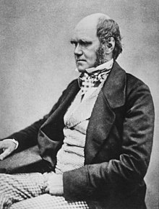Name: Charles Darwin
Dates: Feb 12, 1809 ~ April 19, 1882
Birthplace: England
Field: Naturalist, Geology, Biology
Nobel: NO
Contributions: Theory of Evolution by Natural Selection

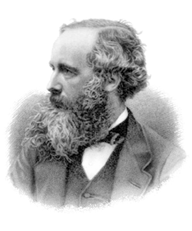Name: James Clerk Maxwell
Dates: June 13, 1831 ~ Nov 5, 1879
Birthplace: Scotland
Field: Mathematical Physics
Nobel: NO
Contributions: Classical theory of electromagnetic radiation (4 equations); Maxwell-Boltzmann distribution for kinetic theory of gasses; colour photography(1861)
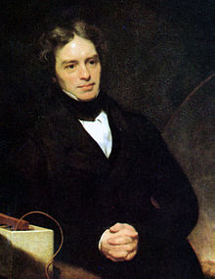Name: Michael Faraday
Dates: Sept 22, 1791 ~ Aug 25, 1867
Birthplace: England
Field: Experimental Physics
Nobel: NO
Contributions: Discovery of Benzene, Electromagnetic Induction (Faraday’s Law), Lines of Force (electrical, magnetic), Magnetism can affect light, electric motors
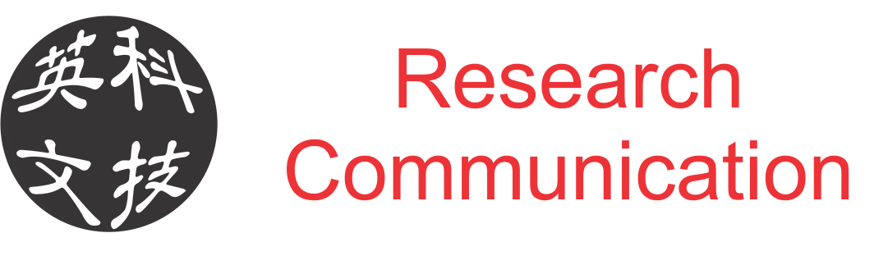

http://www.kejiyingwen.com

http://www.kejiyingwen.com

http://www.kejiyingwen.com

http://www.kejiyingwen.com

Back of the cards below....

